Sri Lanka
06 Nights & 07 Days
Sri Lanka is an Island blessed with beautiful beaches and perfect weather all year round if you’re the kind of person who likes to sit back and soak up the sun and enjoy some fresh seafood. Or maybe you’re more of an explorer who wants to know more about the beautiful aqua-marine creatures and plant life that inhabit the waters of the island. Whatever your preference maybe, we can find something that’s perfect for you. You can now choose from three breathtaking locations and immerse yourself in the absolute tranquil beauty that Sri Lanka has to offer.

Do you know Sri Lanka ranked as No1 Destination in the world to visit?
http://www.lonelyplanet.com/themes/best-in-travel/top-10-countries

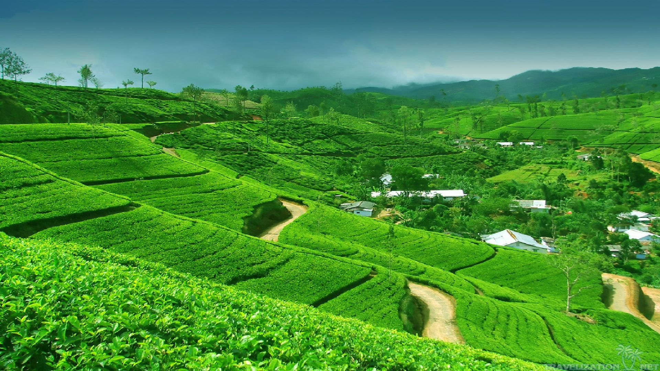

Detail Itinerary

Day 01 – Airport / Kandy Approx 3hr
The ancient city of Kandy, located in Sri Lanka’s centre, is known to be the country’s cultural capital and an example of Sri Lanka’s rich cultural heritage. This beautiful city in the hills is ideal for relaxing and reflecting. The City is home to the tooth relic of the Lord Buddha and it is housed in the famous ‘DaladaMaligawa’ or ‘Temple of the Tooth’, which attracts thousands to the city every year including devotees as well as visitors who come to marvel at the beautiful architecture of the temple. Kandy is also home to many other old temples and other landmarks, including the amazing Peradeniya Botanical Gardens.

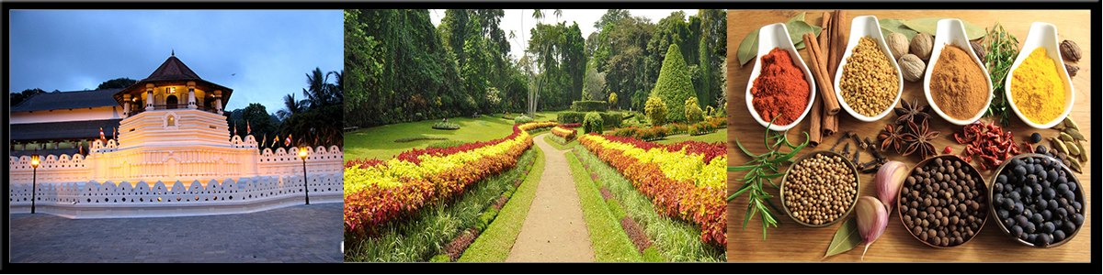

Day 01– Kandy
- Arrival and assistant at the airport proceed to Kandy
- En route visit Pinnawala elephant orphanage and Spice garden
- Check-in at the hotel
- Evening witness the cultural show
- Overnight stay at the hotel

Day 02 & 03 – Kandy / Nuwara Eliya City (Little England) Approx 03hrs

NuwaraEliya, known as the garden city of Asia for its hills, valleys and waterfalls, is 6,182 feet above sea level and is situated at the foot of Mount Pidurutalagala, Sri Lanka's highest peak. NuwaraEliya was discovered in 1819 by Sir Samuel Baker, the famous explore who discovered the source of the Nile. Thereafter, an English village was established, the remains of which can still be seen. The colonial government habitually moved to NuwaraEliya for 3 months of the year: March, April and May, when Colombo was warm and humid. Since then, thousands of domestic and foreign tourists sojourn in NuwaraEliya, to relish the salubrious climate, play golf, enjoy the park, admire the high grown tea plantations, visit the Hakgala gardens grown tea plantations, visit the Hakgala gardens and travel to Worlds End at Horton Plains, where there is a sudden drop in the terrain of several thousand feet.

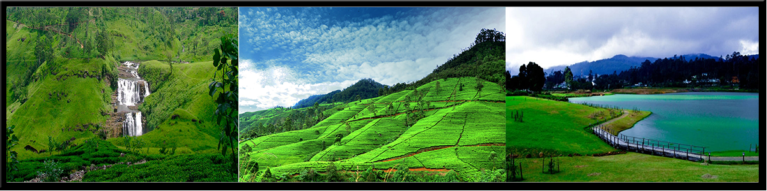
Day 02– NuwaraEliya
- After breakfast at the hotel, Proceed to Nuwaraeliya known as Little England
- En route proceed on Kandy city tour, tea plantations and ramboda water fall
- Visit beautiful waterfalls in Hill country
- Check in to the hotel & relax
- Overnight Stay at the hotel

Day 03– NuwaraEliya
- After breakfast at the hotel, take a day excursion to Ella and proceed with Ella city tour
- Evening return back to Nuwara Eliya
- Overnight stay at the hotel

Day 04 & 05 – Nuwara Eliya / Bentota& Galle (Beach Location) Approx 04hrs
Bentota and its breathtaking sandy beach pretty much transforms your dreams and visions of a tropical paradise into an everyday reality. Located close to the Southern tip of the Island of Sri Lanka and only about 200 km from the Equator, this secluded crescent shaped beach is the perfect place to sit back, relax and forget about all the hustle and bustle of your other life that’s a million miles away. This small sandy tropical beach boasts some of Sri Lanka’s best and most stunning sunsets and sunrises.

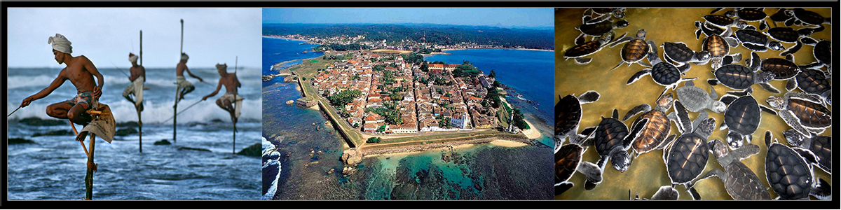

Day 04– Bentota (Beach Area)
- After Breakfast at the hotel, proceed to Bentota
- En route proceed with Nuwara Eliya city tour, visit Gregory’s lake, and Strawberry farm
- Check-in at the hotel
- Evening leisure at the beach
- Overnight stay at the hotel
Day 05– Bentota (Beach Area)
- After breakfast at the hotel take a day excursion to Galle
- Proceed with Galle city tour, Madu river boat ride and Kosgoda turtle farm and Kanda Vihara temple
- Evening return back to hotel
- Overnight stay at the hotel

Day 06 – Bentota& Galle (Beach Location) / Colombo Approx 02hrs
Colombo, the capital of Sri Lanka, brings together the old and the new. Colonial ruins and buildings contrast with high - rise hotels and commercial banks. Almost everyone who visits Sri Lanka spends time in this busy city. Colombo, an eighth century port, houses administrative, financial and other offices of relevance to the traveler. A part of other offices of relevance to the traveler.A part of finest structures of its colonial heritage. The city has developed, through several phases, into a modern city. The populace of Colombo is representative of Sri Lanka's ethnic and religious mixture.

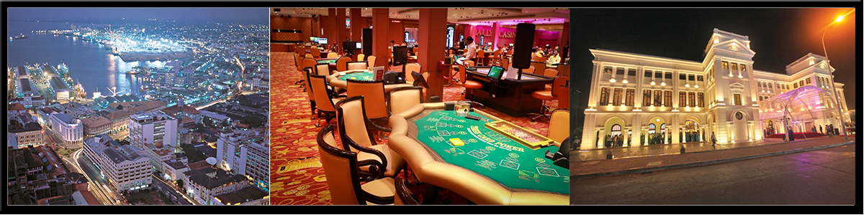
Day 06– Colombo
- After breakfast at the hotel proceed to Colombo
- En route visit Kalutara temple
- Check-in at the hotel
- Evening proceed with Colombo city tour
- Overnight stay at the hotel

Day 07 – Departure
- After Breakfast at the hotel, proceed to Katunayaka International Airport for Departure
- Good bye from Paradise Sri Lanka

Day 07 – Departure

Accommodation Plan – 3*
Days | Location | Hotel Name | Star Category | Room Category | Meal Plan
Day 1 | Kandy | Royal Kandyan | 3 Star | Deluxe | Half Board
Day 2 | Nuwara Eliya | Hotel Ashford | 3 Star | Deluxe | Half Board
Day 3 | Nuwara Eliya | Hotel Ashford | 3 Star | Deluxe | Half Board
Day 4 | Bentota | Earl's Reef | 3 Star | Deluxe | Half Board
Day 5 | Bentota | Earl's Reef | 3 Star | Deluxe | Half Board
Day 6 | Colombo | Ocean Edge | 3 Star | Deluxe | Half Board
Day 7 | Departure

Accommodation Plan – 4*
Days | Location | Hotel Name | Star Category | Room Category | Meal Plan
Day 1 | Kandy | Grand Kandyan | 4 Star | Deluxe | Half Board
Day 2 | Nuwara Eliya | Araliya Red | 4 Star | Deluxe | Half Board
Day 3 | Nuwara Eliya | Araliya Red | 4 Star | Deluxe | Half Board
Day 4 | Bentota | The Palms | 4 Star | Deluxe | Half Board
Day 5 | Bentota | The Palms | 4 Star | Deluxe | Half Board
Day 6 | Colombo | GranBell | 4 Star | Standard Sea view | Half Board
Day 7 | Departure

Accommodation Plan – 5*
Days | Location | Hotel Name | Star Category | Room Category | Meal Plan
Day 1 | Kandy | Golden Crown | 5 Star | Deluxe | Half Board
Day 2 | Nuwara Eliya | Araliya Green City | 5 Star | Deluxe | Half Board
Day 3 | Nuwara Eliya | Araliya Green City | 5 Star | Deluxe | Half Board
Day 4 | Bentota | Cinnamon Bey | 5 Star | Deluxe | Half Board
Day 5 | Bentota | Cinnamon Bey | 5 Star | Deluxe | Half Board
Day 6 | Colombo | Cinnamon Grand | 5 Star | Premier Room | Half Board
Day 7 | Departure

Inclusions (Above Price Includes)
- Airport pick up and drop off
- Assistance at the airport
- Accommodation on half board basis on mention hotels below
- Private luxury van
- English Speaking chauffeur guide for the entire journey
- Kandy city tour
- Colombo city tour
- Nuwara Eliya city tour
- Galle city tour
- Ceylon Gem Factory visit
- Ceylon Batik clothing factory visit
- Sri Lanka Handicraft factory visit
- All government taxes
- Fuel & local insurance for the vehicle

Exclusions (Above Price Excludes)
- Air-tickets NOT included
- Sightseeing entrance charges
- Meals not mentioned in the itinerary
- Camera & video permits
- Travel Insurance is NOT included
- Guide/Driver tips
- Personal expenses
- Late check outs & early check in charges

Flights:
- Not Active on this tour

Additional Information:
- This is only quote and no reservations have been made as yet. All hotels are subjected to availability.

Cancelation Policy
- In case of cancelation, the following cancelation charges will be applicable
- Less than 30 Days 50% of the Total Invoice
- Less than 25 Days 100% of the Total Invoice
- No Show & Early Check - 100% of the Total Invoice

Activity List and Entrance Cost
Sightseeing entrance charges | Rates (In USD)
Turtle Hatchery | $ 3 Per Person
Boat Ride (Madu Ganga) | $ 15 Per Person
Pinnawala elephant orphange | $ 18 per person
Temple of tooth relic kandy | $ 10 per person
Hakgala botanical garden | $ 12 per person
Peradeniya botanical garden | $ 12 per person
Horton plains | $ 70 per person
Water sport one round jet ski, one round banana boat, one round tube boat | $ 25 Per Person

NOTE: The entrance costs of the above activities are not included in package cost

End of Package

